Commercial Microwave—Technical Information

230V, 50 Hz Models

RMS510TS2 P2006703M RMS510DS2 P2006704M
RMS510TSUA P2006707M RMS510DSUA P2006708M
RMS510TSCA P2006709M RMS510TSIA P2006710M
RMS510TSAA P2006711M
Due to possibility of personal injury or property damage, always contact an authorized technician for servicing or repair of this unit.
Refer to Owner’s Manual for installation and operating instructions
To avoid the risk of electrical shock, personal injury or death, disconnect power to oven and discharge capacitor before servicing, unless testing requires power.
WARNING
!

Model | Region | Control | Consumption | Power Source | Plug Type
RMS510TS2 | EMEA, SEA, LATAM | Touch | 1500 W, 7.3 A | 230v, 50hz, 16A | CEE 7/7 “Schuko”
RMS510DS2 | EMEA, SEA, LATAM | Dial | 1500 W, 7.3 A | 230v, 50hz, 16A | CEE 7/7 “Schuko”
RMS510TSUA | EMEA, UK, LATAM | Touch | 1500 W, 7.3 A | 230v, 50hz, 13A | BS1363/A
RMS510DSUA | EMEA, UK, LATAM | Dial | 1500 W, 7.3 A | 230v, 50hz, 13A | BS1363/A
RMS510TSAA | Australia | Touch | 1500 W, 7.3 A | 230v, 50hz, 10A | Type 1
RMS510TSCA | China | Touch | 1500 W, 7.3 A | 230v, 50hz, 16A | China
RMS510TSIA | India | Touch | 1500 W, 7.3 A | 230v, 50hz, 16A | BS546

Models | RMS510D / RMS510T*
Power Output
Nominal microwave energy (IEC705) | 1000 Watts
Minimum temperature rise (∆T) | 10º F / 5º C
Operating Frequency | 2450 MHz
Dimensions
Cabinet
Width | 508mm (20")
Height | 311mm (12 1/4")
Depth | 419mm (16 1/2")
Oven Interior
Width | 330.2mm (13")
Height | 197mm (7 3/4")
Depth | 330.2mm (13")
Weight
Crated | 14.5 kg. (39 lbs.)
Uncrated | 17.7 kg. (32 lbs.)

July 2019 1
©2019 ACP, Inc. 16500066

Component Testing Procedures
To avoid risk of electrical shock, personal injury or death, disconnect power to oven and discharge capacitor before servicing, unless testing requires power.
WARNING
!

Illustration | Component | Test | Results
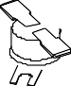 | Thermal Cutout | Disconnect all wires from TCO. Measure resistance across terminals.  Cavity TCO………… ......................................  Magnetron TCO .............................................. | Open at 203° F (95° C) Closes at 185° F (85° C)  Open at 293° F (145° C) Closes at 275° F (135° C)
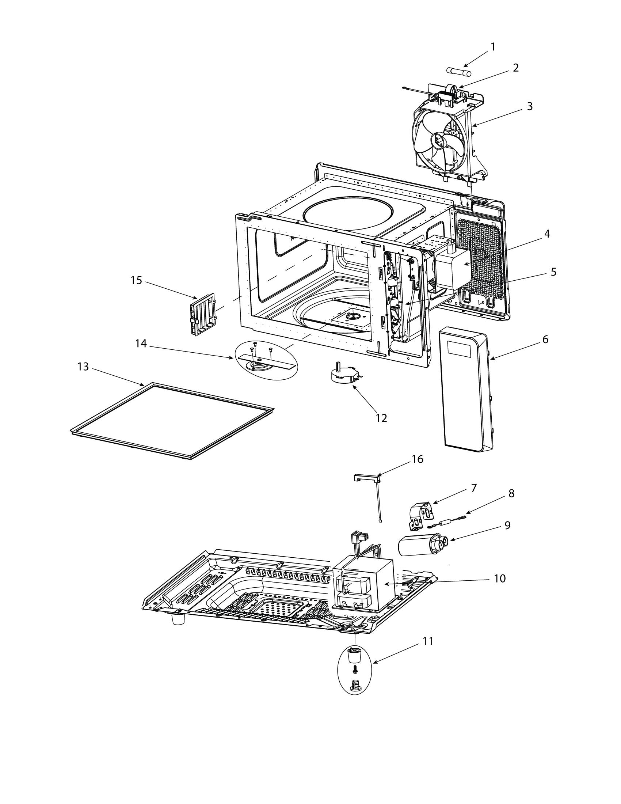 | Diode/Rectifier | Discharge Capacitor  Remove diode lead from capacitor and connect ohmmeter.  Reverse leads for second test. | Infinite resistance should be measured in one direction and 50KΩ or more in the opposite direction.  NOTE: Test meter must contain a battery of 6 volts minimum.
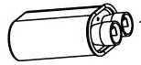 | Capacitor | Discharge Capacitor  Remove wires from capacitor terminals and connect ohmmeter, set on highest resistance scale to terminals.  Also check between each terminal and capacitor case. | Check 1.20uf value for + or – 3%  Between Terminals: Meter should momentarily deflect towards zero then return to over 5 MΩ. If no deflection occurs, or if continuous deflection occurs, replace capacitor.  Terminal to Case: Infinite resistance.
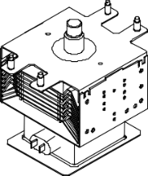 | Magnetron | Discharge Capacitor  Remove wires from magnetron and connect ohmmeter to terminals. Also check between each terminal and ground. | 2M248(J)A –B2  Between Terminals: Less than 1 Ω.  Each terminal to ground measures Infinite resistance.  NOTE: This test is not conclusive. If oven does not heat and all other components test good replace the magnetron and retest.
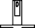 | Stirrer Motor | Remove all wires from terminals.  Measure resistance from:  terminal to terminal...................................... | 230vac 50hz 29.1rpm  Bidirectional  Approximately 4 KΩ.
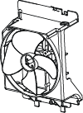 | Blower Motor | Remove all wires from motor.  Measure resistance from terminal to terminal… ....................................................... | Approximately 50 Ω.  230vac 50hz 2800rpm
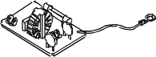 | Fuse block / Filter assembly  20A Fuse | Power In terminals .......................................  Power Out terminals ....................................  Continuity Test | 230 VAC  230 VAC  Rated 20A 250vac
 | LED Lamp | Power across terminals | 230vac = light  48 lumens

Component Testing Procedures
To avoid risk of electrical shock, personal injury or death, disconnect power to oven and discharge capacitor before servicing, unless testing requires power.
WARNING
!

Illustration | Component | Test | Results
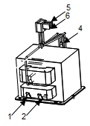 | Transformer  HV Fuse (Terminal 4) | Discharge Capacitors  Remove all wires from terminals. Measure resistance from:  Terminal 1 to Terminal 2..................................  Wire 5 to Wire 6 ...............................................  Terminal 4 to Ground screw on transformer...  Terminal 4 to any other terminal ......................  Resistance | 2.0 Ω.  Less than 1 Ω. 127Ω.  Infinite resistance  Continuity  Rated 700ma 5KV
 | Interlock switch assembly
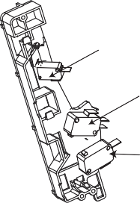  Secondary Interlock Switch  Monitor Interlock Switch |  | With door open measure resistance from:  Terminal C to NO Secondary......................  Terminal C to NC Monitor ...........................  Terminal C to NO Primary / Logic...............  With door closed measure resistance from:  Terminal C to NO Secondary......................  Terminal C to NC Monitor ...........................  Terminal C to NO Primary / Logic............... | Infinite  Continuity Infinite  Continuity  Infinite  Continuity
Primary Interlock Switch
Wire Harness |  | Disconnect wires to switch. | Continuity.

Service Mode

To Check Magnetron Hours or Door Cycles:

- Open door and Press/Hold Pad #3 for 5 seconds or until “SErV” is Displayed

- Press Pad #1 to display Magnetron Hours in 100’s.

- Press Pad #3 to display Door Cycles in 100’s

Power Output Wattage Testing Procedure
To avoid risk of electrical shock, personal injury or death, disconnect power to oven and discharge capacitor before servicing, unless testing requires power.
WARNING
!
All Amana and Menumaster microwave oven power outputs are rated using the IEC705 standards. Using the IEC705 test method requires precision measurements and equipment that is not practical to be performed in the field. Using the test shown below will indicate if the oven performance is satisfactory.

Test equipment required:
- 1000 ml test container and thermometer.
- Digital watch / watch with a second hand for use on ovens with electromechanical timers.

Important Notes:
- Low line voltage will cause low temperature rise / power output.
- Ovens must be on a dedicated circuit, properly grounded, and polarized. Other equipment on the same circuit may cause a low temperature rise / power output.
- This test and results are not a true IEC705 test procedure and are only intended to provide servicers with an easy means of determining if the microwave oven cooking output is correct.
Procedure
- Fill the test container to the 1000 ml line with cool tap water.
NOTE: Water temperature should be approximately 60° F / 16° C.
- Using the thermometer, stir water for five to ten seconds; measure, and record the temperature (T1).
- Place test container of water in the center of oven cavity and close door.
- Heat the water for a 33-second full power cycle.
NOTE: Use a digital watch or a watch with a second hand for ovens with electromechanical timers.
- At end of the cycle, remove test container. Using the thermometer, stir water for five to ten seconds and record temperature (T2).
- Subtract the starting water temperature (T1), from the ending water temperature (T2) to obtain the temperature rise (∆T).
- If the temperature rise (∆T) meets or exceeds the minimum, the test is complete. If the temperature rise (∆T) fails to meet the minimum temperature rise, test the line voltage to verify it is correct. Then repeat steps 1 - 6 making sure to change the water. If the temperature rise (∆T) fails to meet the minimum temperature rise again the oven will require service.

Minimum Temperature Rise at Thirty -Three (33) Seconds Run Time
∆T Cooking  (°F) Power Output | ∆T Cooking (°F) Power Output | ∆T Cooking  (°C) Power Output | ∆T Cooking (°C) Power Output
10 ................. 1000 | 20 ................. 2000 | 5 .............. 1000 | 11............ 2000
11 ................. 1100 | 21 ................. 2100 | 5.5 ............ 1100 | 11.5......... 2100
12 ................. 1200 | 22 ................. 2200 | 6.5 ............ 1200 | 12............ 2200
14 ................. 1400 | 24 ................. 2400 | 7.5 ............ 1400 | 13............ 2400
17 ................. 1700 | 25 ................. 2500 | 9.5 ............ 1700 | 13.5......... 2500
18 ................. 1800 | 27 ................. 2700 | 10 ............. 1800 | 15............ 2700
19 ................. 1900 | 30 ................. 3000 | 10.5 .......... 1900 | 16.5......... 3000

Wiring and Schematic Diagrams
To avoid risk of electrical shock, personal injury or death, disconnect power to oven and discharge capacitor before servicing, unless testing requires power.
WARNING
!


